Lin Hong (洪琳)
Central Oregon Community College
2018
BEGINNING CHINESE
初级汉语课本

Unit 2 Family
家庭
COMMUNICATIVE OBJECTIVES
Once I have mastered this unit, I will be able to:
- in my own and Chinese culture, identify whom people consider to be part of their family;
- describe a family photo;
- ask about someone’s name and family; and
- address people properly.

Module I: Inquiring About Names
模块一：问姓名

Scenario 1.1 : Zhang Wenshan asks a student what his name is.

ZhW:  S: | 你叫什么名字？  我姓安，叫安大为。 | 什么 | shénme | what
ZhW:  S: | 你叫什么名字？  我姓安，叫安大为。 | 名字 | míngzì | given name, full name
ZhW:  S: | 你叫什么名字？  我姓安，叫安大为。 | 安 | Ān | Chinese surname
ZhW:  S: | 你叫什么名字？  我姓安，叫安大为。 | 大为 | Dàwéi | Chinese name of David
Note:

叫 “be called, or be named,” is used to introduce a given name or full name. The pattern is:

Subject + 叫 + Given Name (bi-syllable) / Full Name
我 叫 安大为。
(lit. “I am called An Dawei.”)

Be careful, do not use 是 in this pattern. 叫should not be used to introduce a surname.

什么 a question word, is used to make a question with “What.” Remember not to use 吗 at the end of questions containing question words like What, Where, When, Which, Who, and How. Pay close attention to the word order of Wh- Questions in Chinese. In Chinese questions, the word order is the same as in a statement as follows:

Statement: 我 叫 安大为。 Question: 你 叫 什么？

(lit. “I am called An Dawei.”) (lit. “You are called what”?)

Nevertheless, in English questions, question words (5Wh+How) are switched to the beginning of the questions.

Scenario 1.2: Zhang Guoxin asks the name of a person he does not know in a business reception.

ZhG:  BJ: | 请问，您贵姓？  我姓白，叫白杰森。 | 问 | wèn | to ask
ZhG:  BJ: | 请问，您贵姓？  我姓白，叫白杰森。 | 请问 | qǐng wèn | excuse me
ZhG:  BJ: | 请问，您贵姓？  我姓白，叫白杰森。 | 贵 | guì | honorable, expensive
 |  | 杰森 | Jiésēn | Chinese name of Jason
Note:

请问 literally means “Please may I ask (a question)?” It is commonly used to introduce questions politely, as in the English phrase “Excuse me.” Keep in mind, only use it when asking questions, not to apologize.

您贵姓 literally means “What is your honorable surname?” This idiomatic expression is commonly used to inquire about names on formal occasions when meeting someone for the first time, but would not be used in informal situations. For example, college students would usually ask 你叫什么名字？If someone asks you 您贵姓, you would answer 我姓… followed by your surname. Do NOT use贵 for yourself, because it is an honorific and can only be used to refer to others.

Module II: Inquiring About Age
模块二：问年龄

Scenario 2.1: Zhang Wenshan asks An Dawei how old he is.

ZhW:  AD: | 你多大？  我18岁。 | 多 | duō | how old
ZhW:  AD: | 你多大？  我18岁。 | 大 | dà | big, old
ZhW:  AD: | 你多大？  我18岁。 | 岁 | suì | year of age
Note:  你多大 literally means “You are how big of age?”, and is the most common way to ask someone’s age. When asking someone who is clearly older or senior, you would add 年纪 (niánjì, age) or 岁数 (suìshu, age) to the question, as “Nǐ duōdà niánjì/ suìshu le?  岁 means “year of age” rather than “year.”  Numbers 1-20 |  |  |  |  |  | 狗 | gǒu | dog
  1 yī | 2 èr | 3 sān | 4 sì | 5 wǔ | 6 liù | 7 qī | 8 bā | 9 jiǔ | 10 shí
  11  shí yī | 12  shí’èr | 13  shí sān | 14  shí sì | 15  shí wǔ | 16  shí liù | 17  shí qī | 18  shí bā | 19  shí jiǔ | 20  èr shí

Scenario 2.2: Zhang Wenshan asks a little boy how old he is.

ZhW:  B:  ZhW:  B: | 你几岁？  我八岁。  你属什么？  我属龙。 | 几 | jǐ | how many, how much
ZhW:  B:  ZhW:  B: | 你几岁？  我八岁。  你属什么？  我属龙。 | 八 | bā | eight
ZhW:  B:  ZhW:  B: | 你几岁？  我八岁。  你属什么？  我属龙。 | 属 | shǔ | zodiac
ZhW:  B:  ZhW:  B: | 你几岁？  我八岁。  你属什么？  我属龙。 | 龙 | lóng | dragon
Note:

你几岁is another way to inquire about someone’s age, but it is usually only used to ask the age of children ten years old and younger.

CHINESE ZODIAC The Chinese zodiac is a classification scheme that assigns an animal and its reputed attributes to each year in a repeating 12-year cycle. It and its variations remain popular in many East Asian countries, including China, Japan, South Korea, Vietnam, Mongolia, Cambodia, Laos, Nepal, Bhutan, and Thailand.

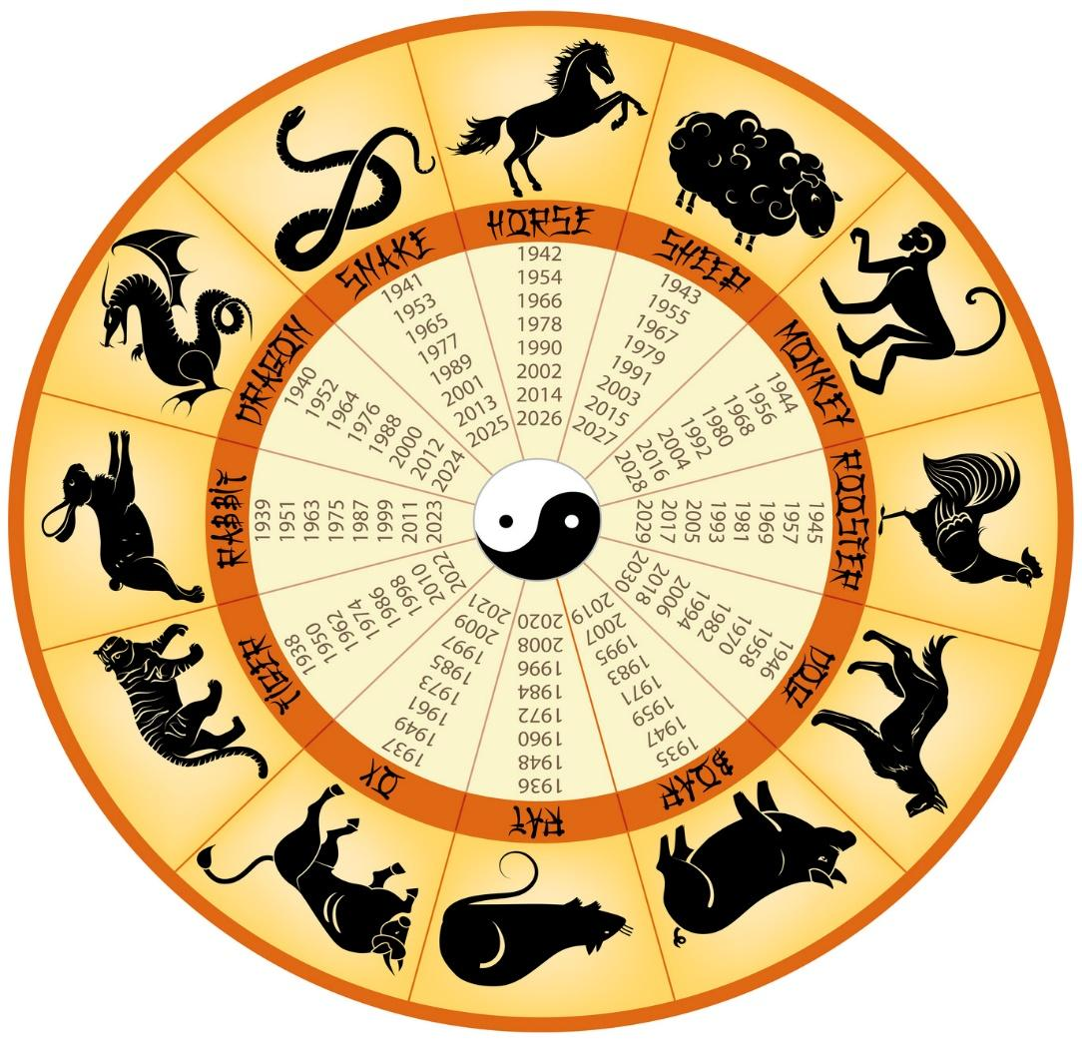
(https://binged.it/2x3uXKb)

Module III: Inquiring About Family Members
模块三：问家人

Scenario 3.1: Zhang Wenshan asks An Dawei how many people are in his family.

ZhW:  AD: | 大为，你家有几口人？  五口人，爸爸、妈妈、哥哥我，和一只狗。 | 家 | jiā | family
ZhW:  AD: | 大为，你家有几口人？  五口人，爸爸、妈妈、哥哥我，和一只狗。 | 有 | yǒu | there is， there are
ZhW:  AD: | 大为，你家有几口人？  五口人，爸爸、妈妈、哥哥我，和一只狗。 | 口 | kǒu | [M] for family members
ZhW:  AD: | 大为，你家有几口人？  五口人，爸爸、妈妈、哥哥我，和一只狗。 | 人 | rén | people, person
ZhW:  AD: | 大为，你家有几口人？  五口人，爸爸、妈妈、哥哥我，和一只狗。 | 爸爸 | bàba | dad
ZhW:  AD: | 大为，你家有几口人？  五口人，爸爸、妈妈、哥哥我，和一只狗。 | 妈妈 | māma | mom
ZhW:  AD: | 大为，你家有几口人？  五口人，爸爸、妈妈、哥哥我，和一只狗。 | 哥哥 | gēge | elder brother
ZhW:  AD: | 大为，你家有几口人？  五口人，爸爸、妈妈、哥哥我，和一只狗。 | 和 | hé | and
ZhW:  AD: | 大为，你家有几口人？  五口人，爸爸、妈妈、哥哥我，和一只狗。 | 只 | zhī | [M] for animals
 |  | 狗 | gǒu | dog
Note:  口 literally means “mouth” in Classical Chinese. The measure word口 is often used when discussing numbers of family members, since they have mouths to feed.  有 a verb, can indicate the existence of something in a certain place. The English sentences starting with “there is” or “there are” are the equivalent. The pattern is:  Place Word + 有 + Noun Phrase  你家 有 口人？  (lit. “In your family, there are how many people”?)  和 a conjunction, can be used only to connect nouns or pronouns, but not verbs or clauses. This usage is different from the English word “and”, which can be used to connect both. For example:  Wǒ yǒu māo hé gǒu. (correct)  I have a cat and a dog. (correct)  * Wǒ yǒu māo, hé yǒu gǒu. (incorrect)  I have a cat, and have a dog. (correct) |  |  |  |  |  | 狗 | gǒu | dog

Scenario 3.2: An Dawei asks Zhang Wenshan if he has siblings.

AD:  ZhW: | 文山，你有兄弟姐妹吗？  我有一个妹妹。 | 兄弟姐妹 | xiōng dì jiě mèi | sibling
AD:  ZhW: | 文山，你有兄弟姐妹吗？  我有一个妹妹。 | 个 | gè | [M]general measure word
AD:  ZhW: | 文山，你有兄弟姐妹吗？  我有一个妹妹。 | 妹妹 | mèimei | younger sister
Note:

个is a measure word. In English, most nouns can be counted directly, i.e., “one dog.” In Chinese a so-called measure word, also called “classifier,” is used between number words (one, two…) ／specifiers (this, that…) and nouns. The pattern is：
Number Word + Measure Word + Noun
一 个 妹妹
(lit. “one younger sister”)

More examples:
一只狗 五口人 这个妹妹
one dog five people this younger sister

There is a variety of measure words. Some of the measure words are only used for a certain group of nouns. 个 is a general measure word that can be used for most nouns.

Module IV: Inquiring About Pets
模块四：问宠物

Scenario 4.1: Li Ming asks An Dawei if he has a pet.

LM:  AD: | 你有宠物吗？  我有一只狗。 | 宠物 | chǒngwù |  | pet

Scenario 4.2: An Dawei asks who likes cats.

AD:  LM: | 谁喜欢猫？  我喜欢猫。 | 谁 | shéi/shuí | who
AD:  LM: | 谁喜欢猫？  我喜欢猫。 | 喜欢 | xǐhuān | to like
AD:  LM: | 谁喜欢猫？  我喜欢猫。 | 猫 | māo | cat

Scenario 4.3: Li Ming asks An Dawei if he likes cats.

LM:  AD: | 你喜不喜欢猫？  我喜欢狗，不喜欢猫。 | 不 | bù | not
Note:

bù (不, not), an adverb, is commonly used to negate verbs and adjectives, like búshì (不是, is not), bù xǐhuān (不喜欢, do not like), bù hǎo (不好, not good). Be careful, to say “do not have”, we will say 没有 (méiyǒu).

Unit Review
单元复习

Can-do Checklist:
After studying this unit, I can:

- recognize and read aloud these words:

什么 名字 安 大为 问 请问 贵 杰森 多 大 岁 几 八 属 龙 家 有 口 人 爸爸 妈妈 哥哥 和 只 狗 兄弟姐妹 个 妹妹 宠物 谁 喜欢 猫 不

- write these characters from memory:

大 几 八 口 人 龙 名 多 和
岁 问 安 家 爸 弟 字 什 狗
- understand when someone asks what a person’s name is.
- understand simple questions about family in correspondence among e-pals.
- understand simple questions that a guest asks about family.
- recognize question words in a text message.
- answer questions about who is in my family.
- name my family members, their ages, and their relationships to me with a photo.
- say the names of my favorite animals based on pictures I see.
- join in a conversation about what pets I like and dislike.
- identify whom I and people in other cultures consider to be part of the family, using a few simple details.

